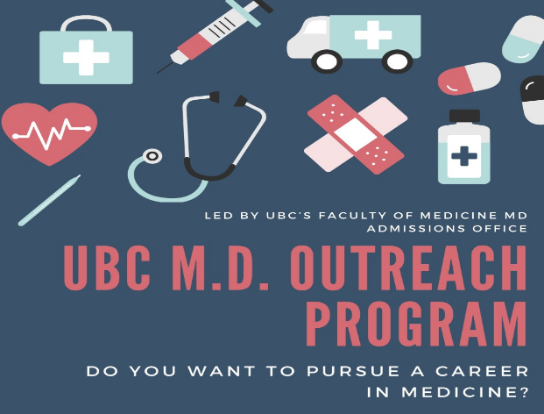
Tips and Advice for those considering pursuing Med School! Shared by Miya Wang, former Semiahmoo student and current MD candidate at UBC

*volunteer/work/show your unique interests in areas that YOU are truly interested in and continue this involvement over time, show growth in character and skills
*your undergraduate degree can be in ANY field (e.g. history, music, engineering), but the MCAT will require you to have science knowledge so taking some of these courses during your undergraduate degree would be useful
*choose your university and program wisely; the well-known pre-med programs often have a competitive environment that isn't the best for mental health/studying, but there may be more opportunities (e.g. research, volunteering). Remember that which university/program DOES NOT matter, only your GPA. Smaller programs & universities will sometimes allow you to achieve the GPA you need in a much easier fashion. And remember geography; being close to family & friends helps a lot. Most medical schools prefer their own province's residents, except Ontario ones.
*it is not ALL about GPA; once you are in the 85%+ range it's your extracurricular things that will set you apart.
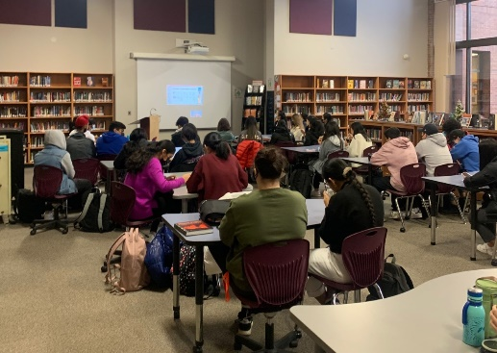
*although IB was great preparation for university it is not necessary; it helps to pre-learn some knowledge, and to get used to the amount of workload/intensity in university. Most of my medical school class didn't do IB
*you can apply for med school after your third year but the majority have an undergraduate degree and it is wise to think what you want your undergraduate degree in as a secondary career option in case you do not get into med school or you change your mind along the way. Most pre-med programs have poor job aspects if you do not get in; and remember that ~80% of applicants don't. Having a non-science undergraduate degree will also often add to your diversity of experience.
*it is a marathon journey - likely taking somewhere between 8-11 years, don't wear yourself out at the beginning of the journey. Also consider if you're okay with being fresh out of school and heavy in debt at ~30 years old, when your non-med friends will likely have established their careers, families, and retirement savings.
*Things/awards you have in high school (other than winning the Olympics) will not matter, the applications will literally not allow you to put in activities in high school. Focus on exploring and finding unique things that you like, that you can really spend time on in university (remember, diversity MATTERS. Anything that sets you apart, even if it's anime; just try to incorporate growth and service, e.g. watching anime -> self-teaching animation -> making clips -> use them to advocate for meaningful things -> awards/recognitions/leaderships?). Pace yourself, find balance, learn to manage your activities, social life and studying - all are very important.

I know that it's tempting to just follow the well-trodden path: science undergrad at a big university, volunteer at a hospital, do some research, travel abroad, become president of a club, etc. Many have succeeded, but you don't hear much about the many who don't. Reality is that the cookie-cutter applicant isn't as competitive anymore; med schools really value diversity and personal growth, and those are best obtained by following your true passions. I personally did not know this and just felt safe doing what every other pre-med is doing, but in the end it was the times that I deviated from the path that set me apart. If it helps, remember that the average pre-med, statistically, does not get in. Keep your GPA high, and explore! And keep your doors open for other career opportunities; the lack of choices after graduation was my major source of anxiety in university.

